testing manual

Virtual job Fair V5.0

Contents

Abstract 2

General Knowledge 2

Backing up before every test 3

General Info about Student Actor Test Cases 4

After running the test 4

Common Tests Failures 5

Common Solution to Test Failures 5

Selenium IDE 6

Conclusions 9

# Abstract

This document will allow you set up and run the integration and regression test for VJF project. I will also give a brief explanation of how to backup/restore the database and what it is assumed before every test. I will describe common error while testing, their causes and solutions. I will show you how to set up your test suite for regression testing and it will explained what should be change when making changes to a view. It will address specific test cases, as their set up is more complicated.

# General Knowledge

Since Selenium IDE performs system test from the client side, it is important to have a clear understanding of what changes in the systems will affects the regression testing. Also, since is script base, if the sequence of the test gets affected then it will result in failing the test case. For example, if ids are changed on the HTML views or new alerts shown, this will impact the scripting because the alert is not being asserted or an html element cannot be found due to its id not being the same one.

All the Student test cases where designed having in mind that the tester have a Gmail user account and the credential for them are stored in the datasource.js file. Since the VJF repository in GitHub is public, we do not upload this file, instead we encrypt and compact it before uploading leaving the original file ignore to the subversion system.

At all tests, it is assumed that you are not logged in to any Google account (meaning that you are logged off before each test begins), and that you are also logged out the phpMyAdmin website in the development environment.

Furthermore, we assume that any of the users created in the Registration test cases (Employer or Student) exists in the database. If this is the case, you need to modify the datasource.js with your test data or delete/modify the dataset in the DB being tested.

Finally, If a test case failed, before attempting to fix it, try to run it again.

# Backing up before every test

Steps:

1. Go to phpMyAdmin
2. Select your DB
3. Click the export tab
4. Click Go
5. Save the File
6. Insert in the first line of the file : CREATE DATABASE IF NOT EXISTS `jobfairdb`;
7. Insert in the second line of the file : USE `jobfairdb`;

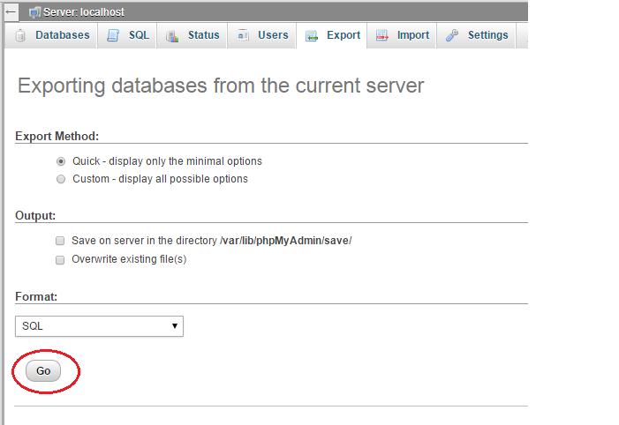

# General Info about Student Actor Test Cases

* **for test 005 the tester must have saved the credential to log in to his FIU google email saved in the browser passwords and his email address must be in the datasource variables for test case 005**
* **for test 006 the tester must have saved his/her credentials to access a linked in account**
* **Email address and password must be in the datasource for test case 006 and must be logged out of the provided google account in the browser for test 007 the tester must have saved the credential to log in to his FIU google email saved in the browser passwords and his email address must be in the datasource variables for test case 007**
* **For test 019 the user must have another Gmail account with a password entered in the datasource. For this we need to automate the fetch of the new password sent to the email or manually enter it in the datasource for the test case and run from the error line forward.**
* **Test 21-28 Enter in the test suite Absolute path for the files to be uploaded in the test (11 files so far). This means the address of the folder in your pc where you can find this files. This is necessary because Selenium IDE has a glitch while evaluating paths.**

# After running the test

Steps:

1. Go to phpMyAdmin
2. Select your DB
3. Go to Import
4. Select the File created Before Testing
5. Click Import

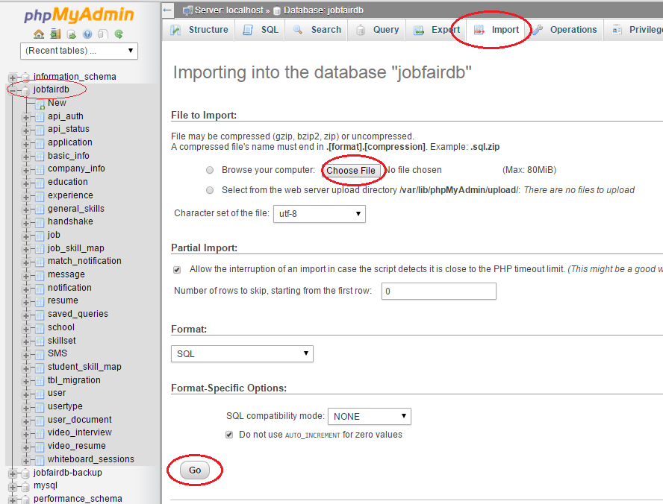

# Common Tests Failures

1. The database already contains the username/email address of the user you are creating.
2. The browser you are using is logged in to a Google account.
3. The browser that you are using is logged in to phpMyAdmin the de dev environment.
4. Internet connection is down or slow.
5. Selenium IDE can’t find and id in the page.
6. Other

# Common Solution to Test Failures

1. Make sure that the user does not exist in the DB. If so, modify your test data in the datasource.js and create a user that email/username does not conflict with an existing user.
2. Log out of google by going to <https://accounts.google.com>.
3. Log out of google by going to <http://vjf-dev.cis.fiu.edu/phpmyadmin>.
4. Usually this will make the response from the system slower and the automated test to not wait properly for elements or pages being ready. So make sure your internet speed is OK.
5. Check that the HTML ids of view being tested were not changed.
6. Other:
   * Check the test case that failed.
   * See which step failed.
   * Check the Log to see the cause.
   * Address the cause of the error.

# Selenium IDE

You need to install Selenium IDE in your computer Firefox browser. After installing the plug in it would look like this:

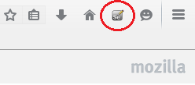

If you click the icon, it would look like this:

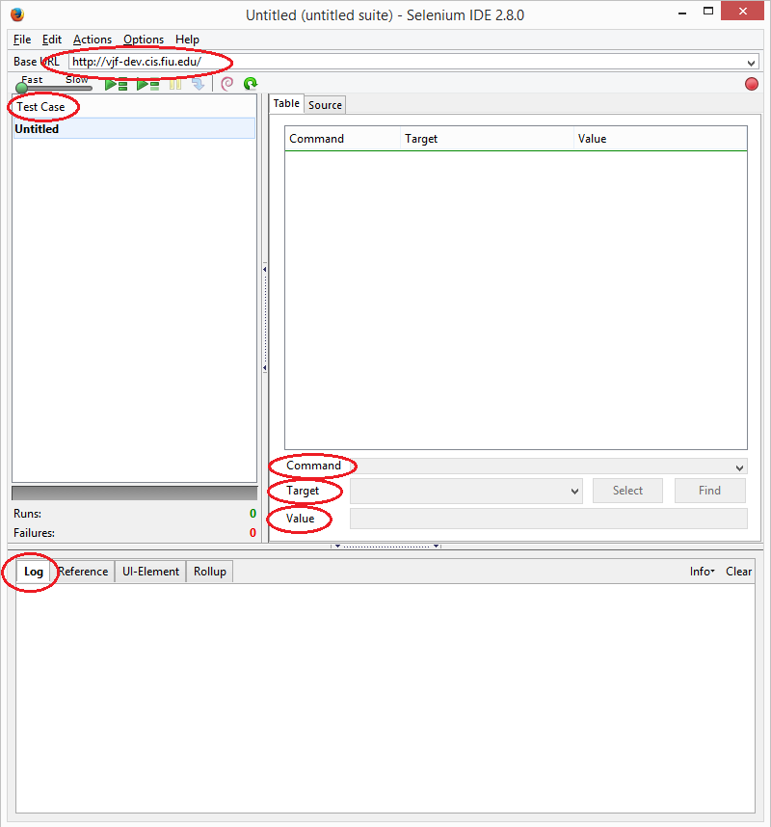

Adding the datasource.js:

1. Click on Options
2. Select Options…
3. Browse the path for the file in Selenium IDE Extensions:

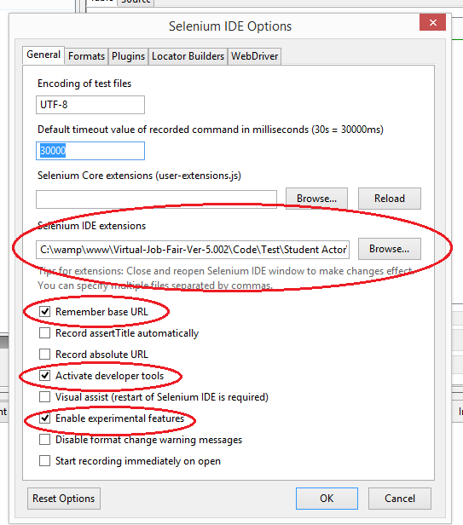

Import the Student Test Suite:

1. Click File.
2. Open Test Suite.
3. Go to the folder where you have downloaded your project
4. Go to Code/Test/Student Actor/ StudentTestSuite

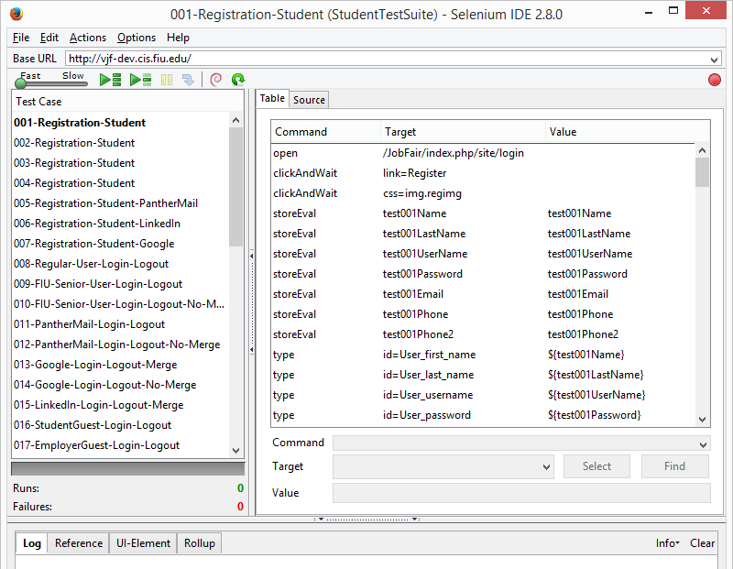

# Conclusions

Remember that this was developed for the Student actor and even though it was just for the Student it involved some interaction with the Employer actor. Any changes in the behavior of the interface of any tested page i.e. throwing alerts, or changing html ids, will result in some tests failing, therefore the script must be updated. You will quickly notice that you need to correct the appropriate script once you start doing regression testing.